Retirement Programme in honour of Shri. Kenilo Apon, IAS, Commissioner & Secretary, DUDA.
On 31st of October, 2025, the Department of Underdeveloped Areas held a farewell programme in honour of Shri. Kenilo Apon, IAS, Commissioner & Secretary, DUDA, at DUDA Administrative Office, Nagaland Civil Secretariat, Kohima. The event was marked by warm tributes and appreciation for his years of leadership and dedication. During his tenure, Shri. Kenilo Apon, IAS, was instrumental in strengthening administrative coordination, overseeing developmental initiatives and mentoring Officers in the State.
Speaking on the function, the Director, DUDA and other senior Officers of the Department recalled his commitment, steady guidance and approachable nature, describing him as both a capable administrator and a valued mentor. Shri. Kenilo Apon, IAS, in his farewell remarks expressed his gratitude to the Government of Nagaland and his colleagues for their support throughout his career. He also encouraged the Officers and staff of the Department to continue their commitment to the service and overall development in the years ahead.
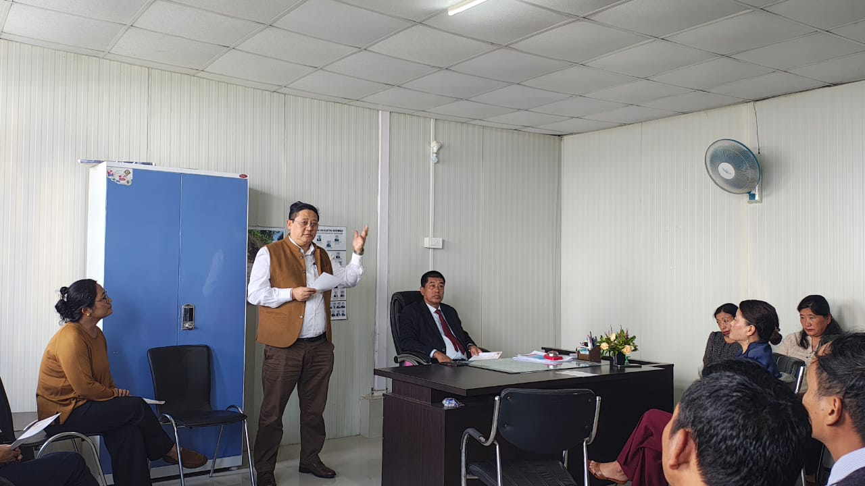
Welcome Address, Shri. T. Wati Aier, NCS, Director, DUDA.
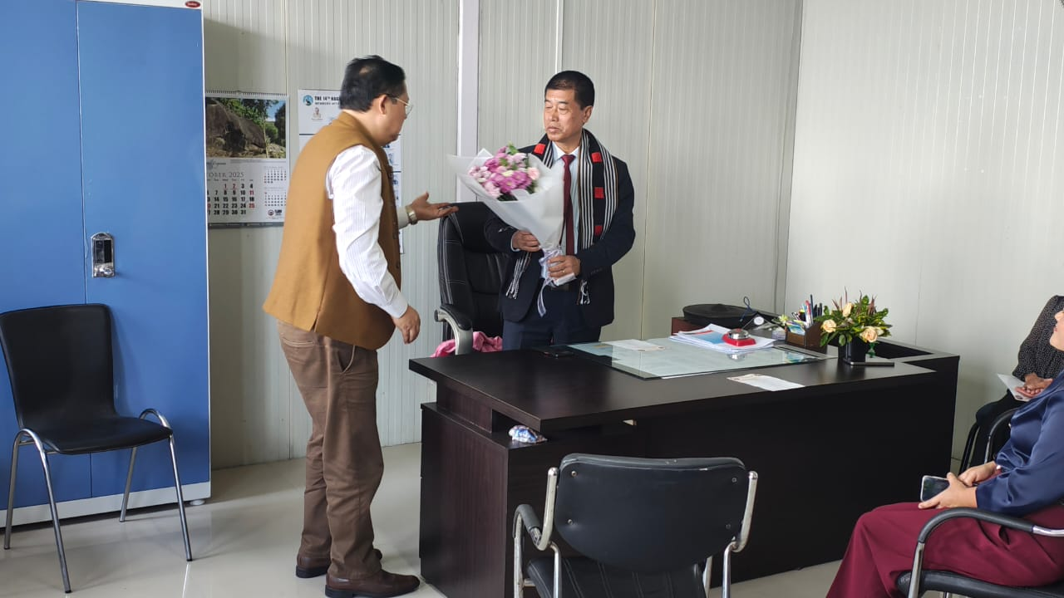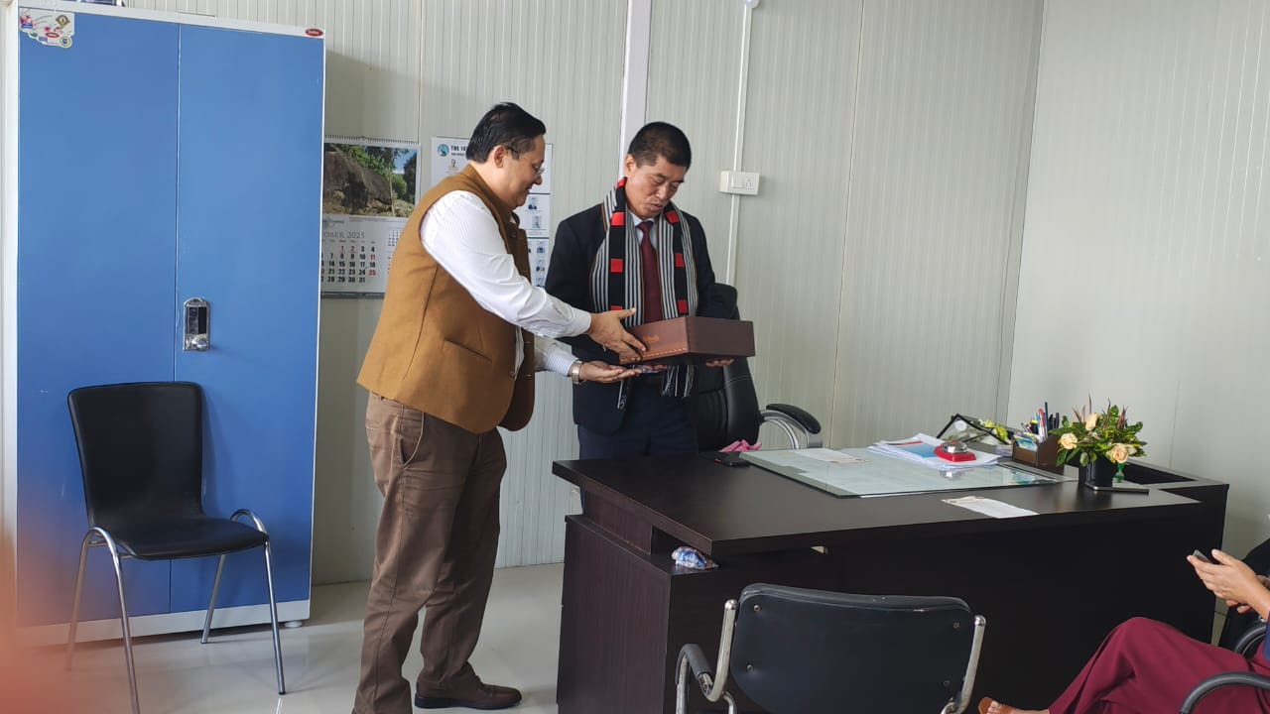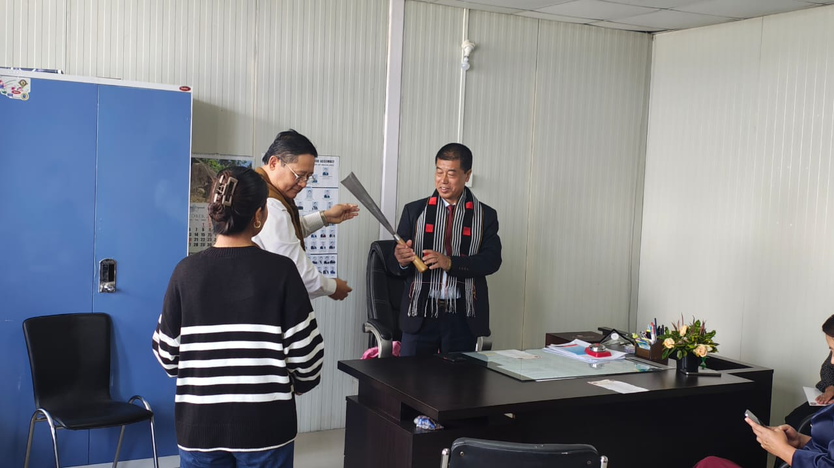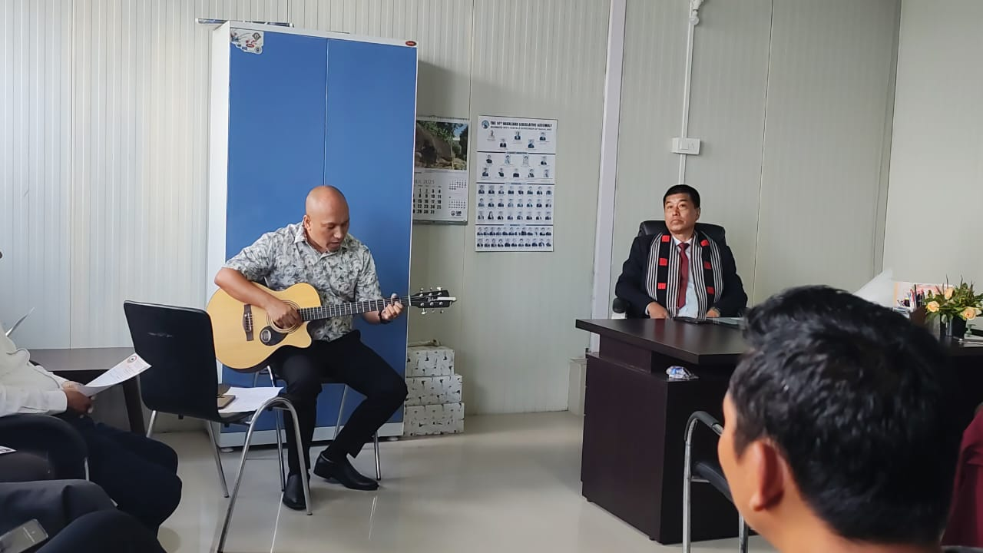
Presentation to Shri. Kenilo Apon, IAS, Commissioner & Secretary, DUDA
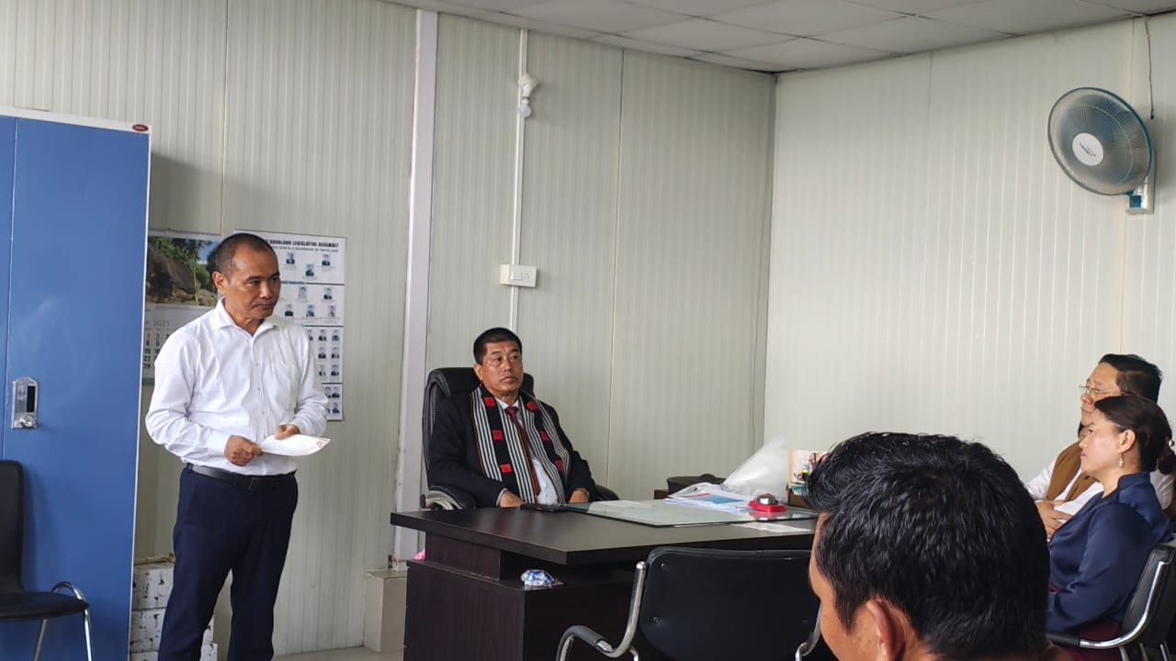
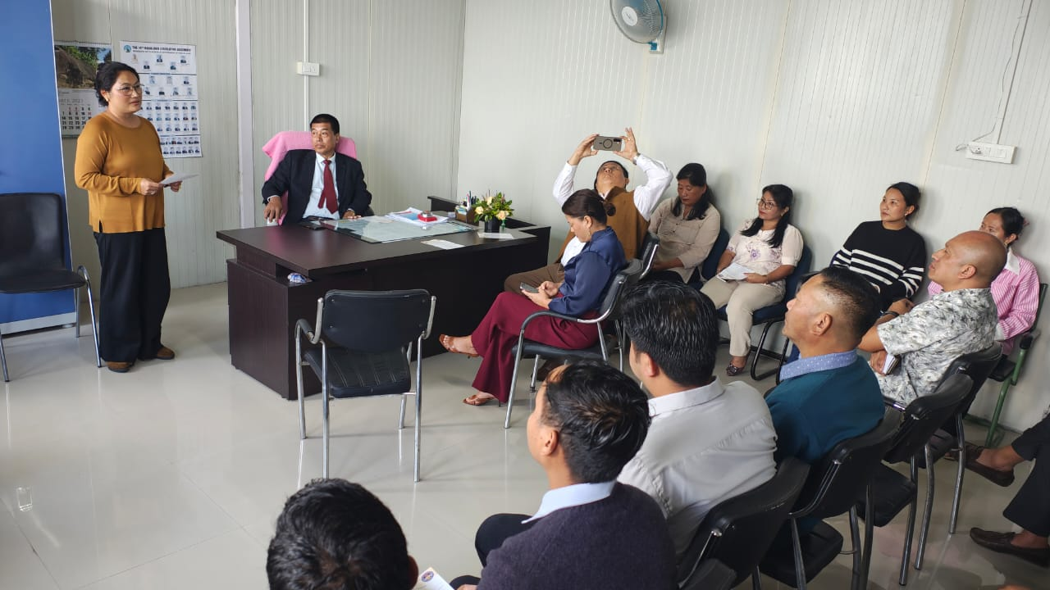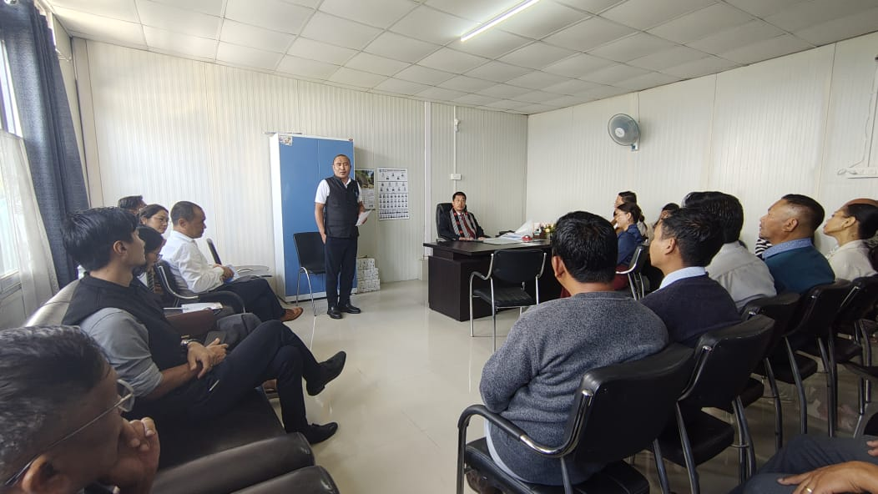
Speeches from the Officers of the Department

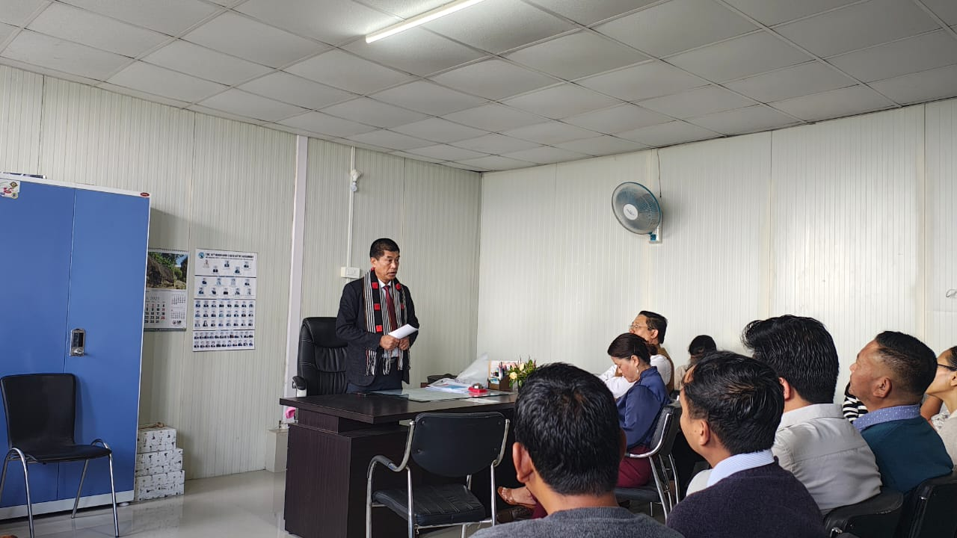
Farewell Speech from Shri. Kenilo Apon, IAS, Commissioner & Secretary, DUDA

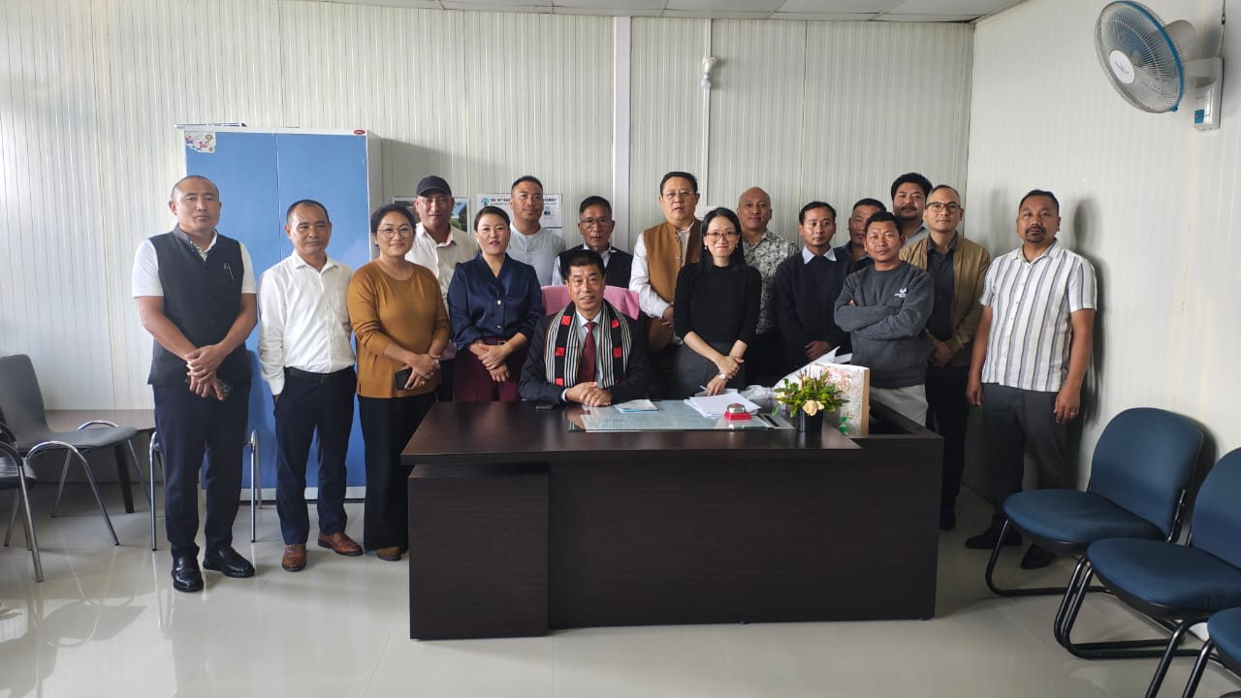
Shri.Kenilo Apon, IAS, Commissioner & Secretary, DUDA with Officers and staff of the Department

